**Social Engineering**

Social Engineering - Psychological manipulation. It is exploiting a set of human weakness.

* Media
* Advertising
* Kids
* Sales

Intent

Malicious Intent

Computer Based Social Engineering

Human Based Social Engineering

The largest firm accounted from 30000 leaked emails address alone

Researchers say most of the addresses were not directly stolen but came from 3rd Party Data breaches

Email and password combinations for websites such as LinkedIn can be used by attackers to slip past business defenses.

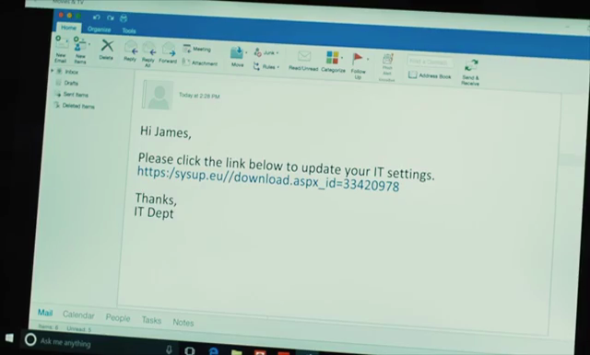

Spear Phishing

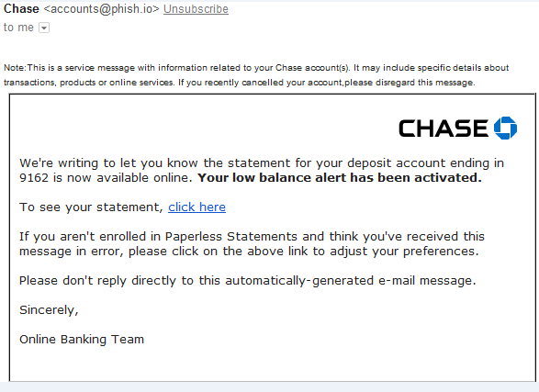

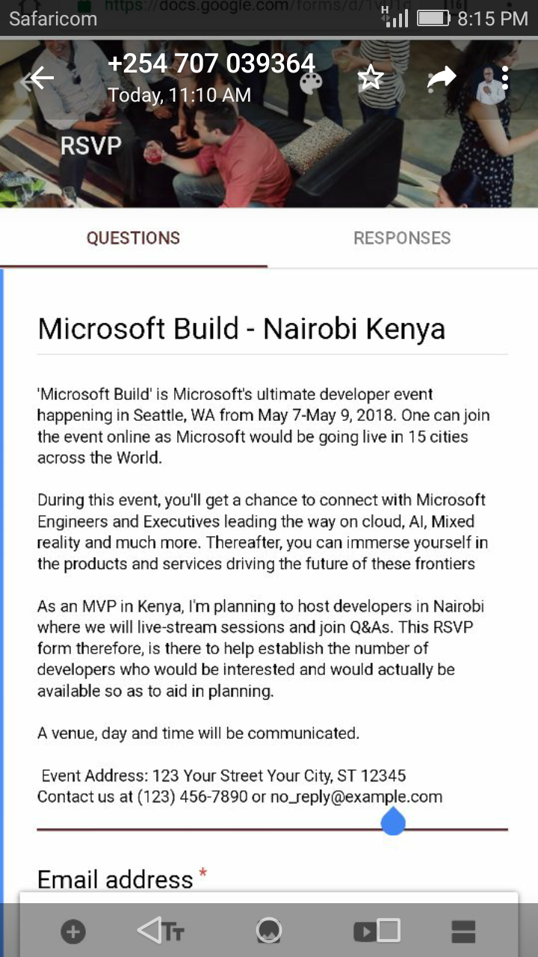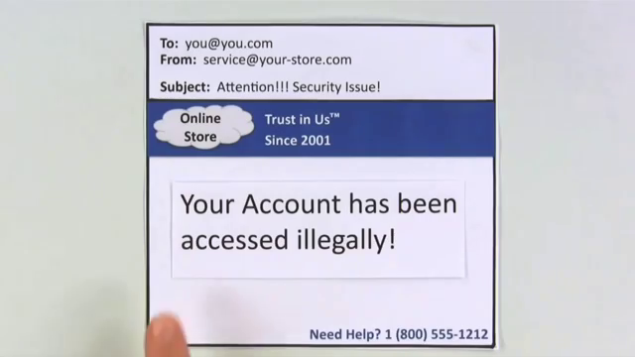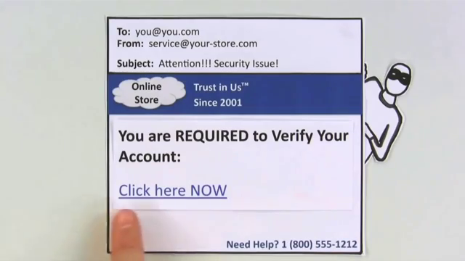

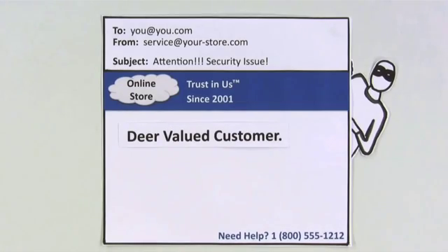

https://yspcjis.net/menu